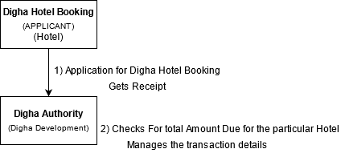

Description:-

At first Digha Hotel login’s with their particular credentials provided by the officials.

Hotel Authority fills up the application with detail of the no. of visitors.

**Step 1:** Then Apply For Digha Hotel Booking Service and would get a receipt of no. of person allotted in hotel.

**Step 2:**

Digha Development Authority can check the total No. of visitors visited the hotel and the amount of money due till date to be paid by particular hotel authority.

Manages the Offline Transactions details and update.

**Note:**

**Report: -**

* Digha Development Authority can check the Total No. of visitors visited Digha monthly/yearly by date.
* Can also view in respect/sort by hotel names.
* Pending dues with respect of hotels.